**SPRINT 3**

**REVIEW**



**Author: Imagineers Team**

**Date: 29/03/2017**

**Revision history**

|  |  |  |  |
| --- | --- | --- | --- |
| **Version** | **Date** | **Author** | **Notes** |
| **1.0** | 29/03/2017 | Thạch Nguyễn |  |
|  |  |  |  |
|  |  |  |  |

**TABLE OF CONTENT**

I. SPRINT 2- BACKLOG 4

II. SPRINT 2- BURNDOWN 4

III. SPRINT 2- TASK REPORT 5

IV. SPRINT 2- CHECKLIST 7

V. SPRINT 2- SUMMARY 9

# SPRINT 3- BACKLOG

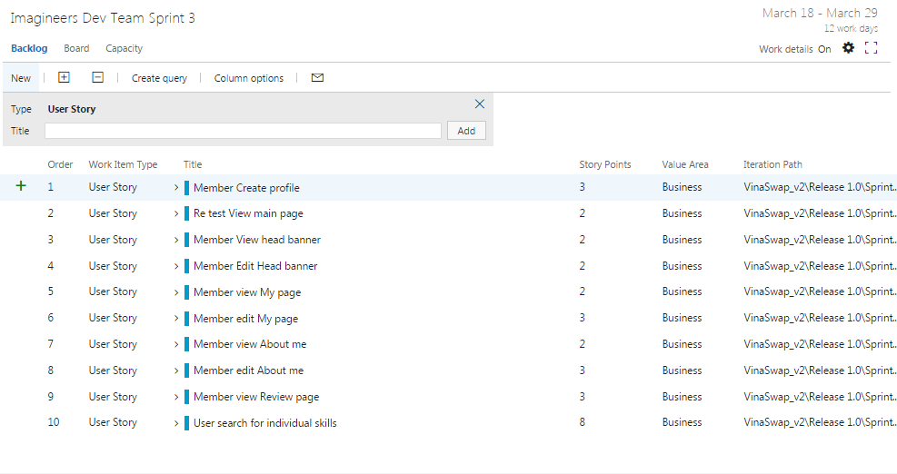

# SPRINT 3- BURNDOWN

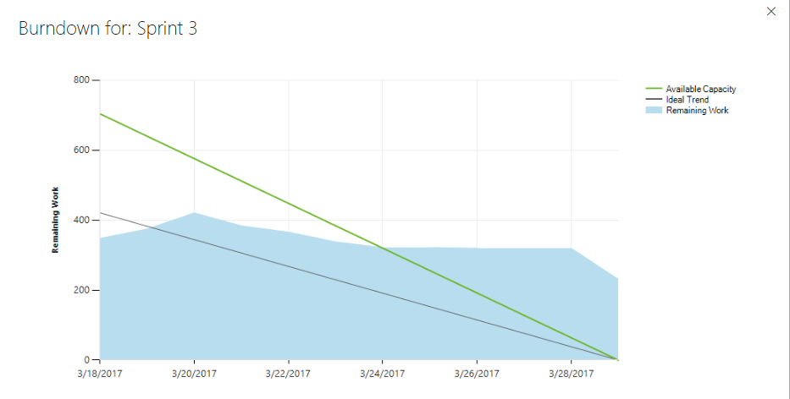

* Total estimated effort hours: 499 hours
* The actual effort hours: 266 hours
* The undone tasks hours: 233 hours

# SPRINT 3- TASK REPORT

|  |  |  |  |  |  |
| --- | --- | --- | --- | --- | --- |
| User story | Task | Assigned | Estimation (hrs) | Actual  (hrs) | Status |
| Member Create profile | Write Unit test – create profile server side | Tai Nguyen | 4 | 2 | Done |
|  | Run unit test – create profile server side | Tai Nguyen | 4 | 2 | Not done |
|  | Write Unit test – create profile client side | Tai Nguyen | 4 | 2 | Done |
|  | Run Unit test – create profile client side | Tai Nguyen | 4 | 2 | Not done |
|  | Code HTML/CSS – create profile | Quang Nguyen | 8 | 4 | Done |
|  | Code client side– create profile | Quang Nguyen | 16 | 4 | Not done |
|  | Review code | Chanh Tran | 2 | 0 | Not done |
|  | Run functional test case- create profile | Viet Dang | 4 | 1 | Done |
|  | Write acceptance test – create profile | Phuong Nguyen | 1 | 1 | Done |
|  | Write test report – create profile | Viet Dang | 2 | 1 | Done |
|  | Build Deploy | Thach Nguyen | 2 | 1 | Done |
|  |  |  |  |  |  |
| Retest view main page | Write Unit test – view main page server side | Tai Nguyen | 4 | 2 | Done |
|  | Run Unit test – view main page server side | Tai Nguyen | 4 | 2 | Done |
|  | Write unit test – view main page client side | Tai Nguyen | 4 | 1 | Done |
|  | Run unit test – view main page client side | Tai Nguyen | 4 | 1 | Done |
|  | Write acceptance test | Phuong Nguyen | 1 | 1 | Done |
|  | Run functional testcase – view main page | Viet Dang | 2 | 1 | Done |
|  |  |  |  |  |  |
| Member view head banner | Code client side – view head banner | Quang Nguyen | 8 | 8 | Done |
|  | Code HTML/CSS | Viet Dang | 8 | 6 | Done |
|  | Write unit test – server side | Tai Nguyen | 4 | 4 | Done |
|  | Run unit test – server side | Tai Nguyen | 4 | 2 | Done |
|  | Write unit test – client side | Tai Nguyen | 4 | 4 | Done |
|  | Run unit test – client side | Tai Nguyen | 4 | 2 | Done |
|  | Review code | Chanh Tran | 2 | 1 | Done |
|  | Write test report – view head banner | Viet Dang | 2 | 1 | Done |
|  | Build – view head banner | Thach Nguyen | 2 | 2 | Done |
|  |  |  |  |  |  |
| Member edit head banner | Code client side – edit head banner | Quang Nguyen | 12 | 8 | Done |
|  | Code HTML/CSS | Viet Dang | 8 | 4 | Done |
|  | Code server side | Chanh Tran | 16 | 8 | Done |
|  | Review code | Chanh Tran | 2 | 1 | Done |
|  | Write test report – edit head banner | Viet Dang | 2 | 1 | Done |
|  | Run functional test – edit head banner | Viet Dang | 4 | 2 | Done |
|  | Write acceptance test | Phuong Nguyen | 1 | 1 | Done |
|  | Write Unit test – edit head banner client side | Tai Nguyen | 4 | 2 | Done |
|  | Run unit test – edit head banner client side | Tai Nguyen | 4 | 2 | Done |
|  | Write Unit test – edit head banner server side | Tai Nguyen | 4 | 2 | Done |
|  | Build deploy – edit head banner | Thach Nguyen | 2 | 2 | Done |
|  |  |  |  |  |  |
| Member view my page | Code HTML/CSS | Quang Nguyen | 8 | 8 | Done |
|  | Code client side – view my page | Quang Nguyen | 12 | 8 | Done |
|  | Code server side – view my page | Chanh Tran | 10 | 8 | Done |
|  | Write unit test – view my page client side | Tai Nguyen | 4 | 4 | Done |
|  | Run unit test – view my page client side | Tai Nguyen | 4 | 2 | Done |
|  | Write unit test – view my page server side | Tai Nguyen | 4 | 4 | Done |
|  | Run unit test – view my page server side | Tai Nguyen | 4 | 2 | Done |
|  | Write acceptance test | Phuong Nguyen | 1 | 1 | Done |
|  | Run functional test – view my page | Viet Dang | 2 | 1 | Done |
|  | Build – view my page | Thach Nguyen | 2 | 2 | Done |
|  | Write test report | Viet Dang | 2 | 1 | Done |
|  |  |  |  |  |  |
| Member edit my page | Code HTML/CSS | Quang Nguyen | 8 | 3 | Done |
|  | Code client side – edit my page | Quang Nguyen | 12 | 3 | Undone |
|  | Code server side – edit my page | Chanh Tran | 16 | 8 | Done |
|  | Write unit test – edit my page client side | Tai Nguyen | 4 | 2 | Done |
|  | Run unit test – edit my page client side | Tai Nguyen | 4 | 1 | Not Done |
|  | Write unit test – edit my page server side | Tai Nguyen | 4 | 2 | Done |
|  | Run unit test – edit my page server side | Tai Nguyen | 4 | 2 | Not Done |
|  | Write acceptance test | Phuong Nguyen | 1 | 1 | Done |
|  | Run functional test | Viet Dang | 4 | 1 | Done |
|  | Build – edit my page | Thach Nguyen | 2 | 2 | Done |
|  |  |  |  |  |  |
| Member view about me | Code HTML/CSS | Quang Nguyen | 8 | 8 | Done |
|  | Code client side – view about me | Quang Nguyen | 12 | 12 | Done |
|  | Code server side – view about me | Chanh Tran | 12 | 10 | Done |
|  | Write unit test – view about me client side | Tai Nguyen | 4 | 10 | Done |
|  | Run unit test – view about me client side | Tai Nguyen | 4 | 3 | Done |
|  | Write unit test – view about me server side | Tai Nguyen | 4 | 13 | Done |
|  | Run unit test – view about me server side | Tai Nguyen | 4 | 3 | Done |
|  | Run functional test | Viet Dang | 4 | 2 | Done |
|  | Write acceptance test | Phuong Nguyen | 1 | 1 | Done |
|  | Build – view about me | Thach Nguyen | 2 | 2 | Done |
|  |  |  |  |  |  |
| Member edit about me | Code HTML/CSS | Quang Nguyen | 8 | 3 | Done |
|  | Code client side – edit about me | Quang Nguyen | 12 | 4 | Not Done |
|  | Code server side – edit about me | Chanh Tran | 12 | 4 | Not Done |
|  | Write unit test – edit about me client side | Tai Nguyen | 4 | 4 | Done |
|  | Run unit test – edit about me client side | Tai Nguyen | 4 | 0 | Undone |
|  | Write unit test – edit about me server side | Tai Nguyen | 4 | 4 | Done |
|  | Run unit test – edit about me server side | Tai Nguyen | 4 |  | Undone |
|  | Run functional test | Viet Dang | 2 | 2 | Done |
|  | Write acceptance test | Phuong Nguyen | 1 | 1 | Done |
|  | Build – view about me | Thach Nguyen | 2 | 2 | Done |
|  |  |  |  |  |  |
| Member view review page | Code HTML/CSS | Quang Nguyen | 8 | 4 | Done |
|  | Code client side – view review page | Quang Nguyen | 8 |  | Undone |
|  | Code server side – view review page | Chanh Tran | 8 |  | Undone |
|  | Write unit test – view review page client side | Tai Nguyen | 4 | 2 | Done |
|  | Run unit test – view review page client side | Tai Nguyen | 4 |  | Undone |
|  | Write unit test – view review page server side | Tai Nguyen | 4 | 2 | Done |
|  | Run unit test – view review page server side | Tai Nguyen | 4 |  | Undone |
|  | Run functional test | Viet Dang | 2 | 1 | Done |
|  | Write acceptance test | Phuong Nguyen | 1 | 1 | Done |
|  | Build – view review page | Thach Nguyen | 2 | 1 | Done |
|  |  |  |  |  |  |
| User search for individual skills | Design UI | Phuong Nguyen | 8 | 4 | Done |
|  | Design database | Thach Nguyen | 8 | 2 | Note done |
|  | Code HTML/CSS | Quang Nguyen | 8 | 0 | Undone |
|  | Code client side – search skills | Quang Nguyen | 12 | 3 | Note done |
|  | Code server side – search skills | Chanh Tran | 8 | 0 | Undone |
|  | Write unit test – search skills client side | Tai Nguyen | 4 | 0 | Undone |
|  | Run unit test – search skills client side | Tai Nguyen | 4 | 0 | Undone |
|  | Write unit test – search skills server side | Tai Nguyen | 4 | 0 | Note done |
|  | Run unit test – search skills server side | Tai Nguyen | 4 | 0 | Undone |
|  | Run functional test | Viet Dang | 4 | 0 | Undone |
|  | Write acceptance test | Phuong Nguyen | 1 | 1 | Undone |
|  | Build – search skills | Thach Nguyen | 2 | 0 | Undone |

# SPRINT 3- CHECKLIST

|  |  |  |  |
| --- | --- | --- | --- |
| Category | Detail | Artifacts | Status |
| User Story Clarity | User stories selected for the sprint are complete with respect to product theme, understood by the team, and have been validated by the detailed acceptance criteria. | Product backlog/ User story | Done |
| Tasks Identified | Tasks for selected user stories have been identified and estimated by the team. - |  | Done  Each story or task has ID  Task ID conduct on team service tool |
| Product owner approval | Each finished user story has been passed through UAT (User Acceptance Testing) and signed off as meeting requirements | References : Acceptance test | Imagineers-AcceptanceTest |
| Updating Product Backlog | All features not done during the sprint are added back to the product backlog. All incidents/defects not handled during the sprint are added to the product backlog. | Imagineers-BacklogRefinement | Done |
| Environment ready | Development environment is ready with all third-party tools configured.  Staging environment is ready.  Continuous integration framework is in place  Test data for the selected features has been created | Task management : Team service  Coding: Visual code  Document: Microsoft Office  Configuration tool: GitHub |  |
| Design complete | Design analysis is complete as per the user story or theme.  Prototype have been created and approved by the respective stakeholders.  Use cases are developed | Imagineers-Usecase  Imagineers-Prototype | Complete 100% story designs and use cases |
| Unit test cases written | Unit test cases have been written for the features to be developed |  | Developed :   * Member Create profile * Retest view main page * Member view head banner * Member edit head banner * Member view my page * Member edit about me * Member view review page   Undone   * Search skills |
| Documentation Ready | Documentation to support the sprint demo is ready |  |  |
| Code Complete | Source code changes are done for all the features in the “to do” list.” Source code has been commented appropriately. |  | Not complete with   * Member Create profile * Member edit my page * Member edit about me * Member view review page * User search for individual skills |
| Unit testing is done | Unit test cases have been executed and are working successfully |  | Not complete with   * Member Create profile * Member edit my page * Member edit about me * Member view review page * User search for individual skills |
| Code Refactoring | Source code has been refactored to make it comprehensive, maintainable and, amenable to change. |  | Done in GitHub |
| Code checkin | Source code is checked in the code library with appropriate comments added. |  | Done in GitHub |
| Code merging and tagging | Finalized source code has been merged with the main branch and tagged appropriately (merging and tagging guidelines are to be used) |  | Done in GitHub |
| Project metrics are ready | Burndown chart has been updated regularly and is up to date. |  | Burndown chart is developed |
| Functional testing done | Test team has reviewed and conducted necessary manual test cases to ensure that tests are passing. All incidents/defects are reported.  100% executed test cases and 80% test cases pass.  There are no major defect occurred  Accept 20% minor defects in layout or the defect doesn’t affect system | Imagineers-TestCase  Imagineers-TestReport | Undone:   * Search skills |
| Acceptance testing done | Each finished user story has been passed through UAT (User Acceptance Testing) and signed off as meeting requirements (see also Product Owner Approval). | Imagineers-AcceptanceTest | Acceptance test   * View about me * View my page * View introduction line * Edit introduction line |
| Closure | All finished user stories/tasks are marked complete/resolved. Remaining hours for task set to zero before closing the task. |  | There are a lot of undone task  Reference on III.Task Report |

# SPRINT 3- SUMMARY

* There are a lot of undone task leads to failure in done the stories ( Reference in III. Task Report)
* The undone stories is sent back to the backlog for further development
* Code checking and refactoring
* Selected too much user story in this sprint leads to undone stories
* Tasks are not well defined and updated
* Team needs to fix this right away. If not it can cause the product to not finish on time